# A proposed review to identify hypothesised causes of the observed decrease in teenage pregnancies in the UK

## Background

Rates of teenage pregnancy have decreased in Scotland, England and Wales across the last 18 years (Figure 1). Similar declines are noted in other counties (Sedgh, Finer, Bankole, Eilers, & Singh, 2015) Across the academic, grey and popular literature, a number of causes of the reducing rate have been proposed (Girma & Paton, 2015; Hadley, Ingham, & Chandra-Mouli, 2016; The Economist, 2018; Triggle, 2018).

These include both interventions and macro/cultural changes. In order to assess the relative impacts of plausible hypothesised causes, observed data from across several countries could be compared alongside measures of exposure to each cause varying year by year. This will be termed the Natural Experiment approach, treating differential exposures as cases and controls. A causal diagram constructed from prior knowledge of hypothesised causes would be a necessary first stage in identifying what data would be required and how to analyse these to evaluate each of these (Hernán & Robins, 2018).

Figure 1 Changes in conception rates amongst teenage women from 1994 to 2015. (Information Services Division, 2017; Office for National Statistics, 2017)

## The need for a review

No robust assessment of all hypothesised causes is yet known to have been conducted. A review would aim to identify all hypothesised causes shown by current evidence to be feasibly associated with the observed fall in pregnancy rates.

## The scope of the review

The scope of the review will be limited by the scope of the natural experiment. To ensure accessibility of useable data on conceptions for comparison and to avoid excessive numbers of unmeasured cultural confounders, countries for comparison will be limited to the 31 European countries included in Euro-Peristat (2012), plus the U.S.A. and Canada.

The time period considered by this review will be from 1990 to the present day. This would aim to focus on most recently observed trends observed and commented on by researchers elsewhere (Kost, Maddow-Zimet, & Arpaia, 2017; Paton, 2012; Wellings et al., 2016).

## Identifying causes

In the cases of interventions, the design and purpose of these to reduce the risk of teenage pregnancies should ideally produce a logic model to describe a causal pathway. In each intervention, distinct actions of ‘input’ can be categorised as an identifiable causal pathway.

In the cases of exposures to macro, cultural-level changes, the causal pathways are harder to distinguish and arguably don’t have a ‘root cause’ in continually changing human societies. These will be grouped by theorised causal pathways. ‘Input’ root causes used to define each pathway will be identified as changes in macro/cultural contexts between time periods recording different rates and trends (Figure 2).

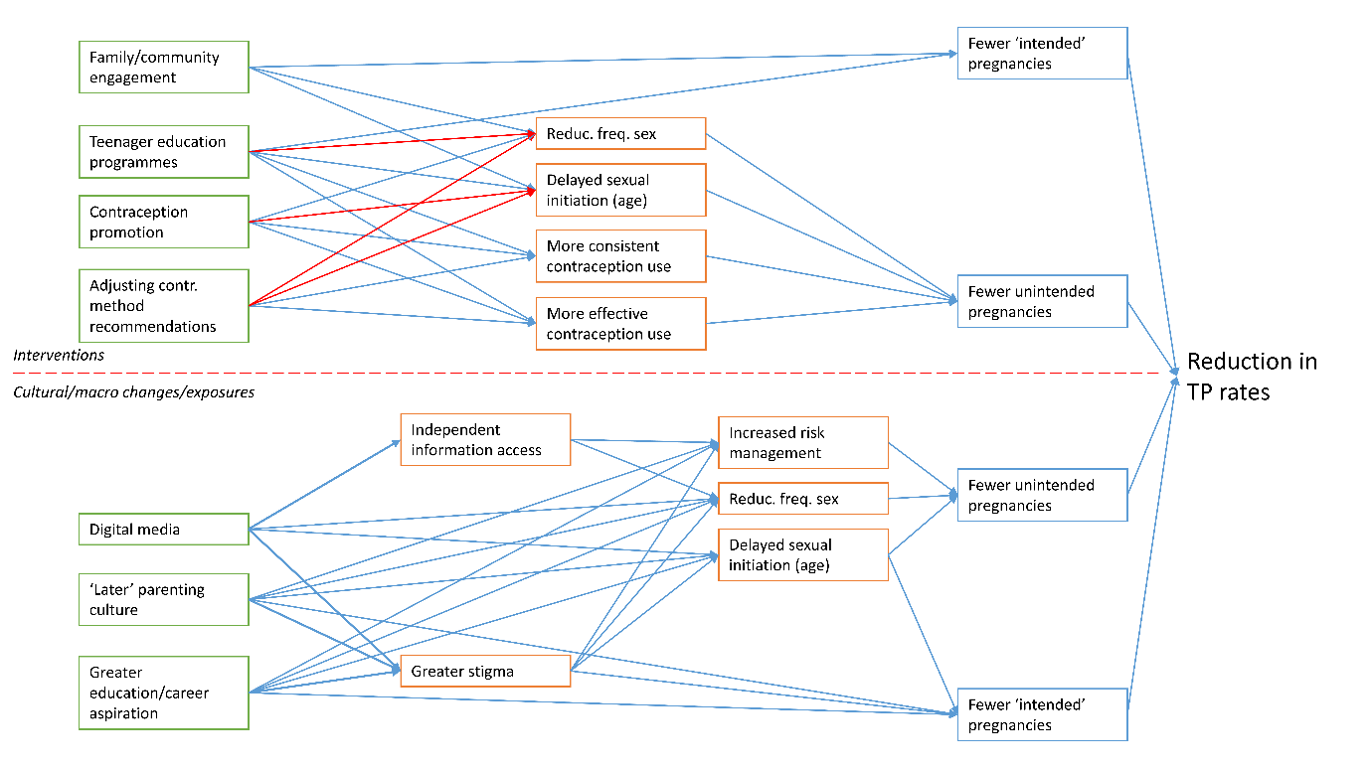



Figure 2 Initial construction of hypothesised pathways to be adapted and amended by review

Intervention pathways detailed above the line are grouped by ‘input’ steps (green boxes), distinct actions taken, rather than by policies or initiatives (which may prompt several, concurrent inputs). Macro exposures below the line are grouped broadly by theorised pathways.

Each potential cause will be analysed according to criteria for assuming causation. These are adapted from those developed by Hill (1965) to attempt to assess the population-wide observations. The criteria used will be defined as follows:

* Temporal Relation – has a cultural change or introduction of an intervention preceded an observed reduction in rates?
* Plausibility – what is the strength of evidence for a causal pathway? Is a logic model available or constructible from presented data?
* Consistency – have other contexts seen the same effects of this intervention or change?
* Dose-response relationship – depending on the intervention or change of exposure being presented, is it possible to test and observe varying strengths of exposure in relationship to the outcome?
* Evidence available – strength of study design, consistency of reported outcomes and number of studies found through the review process.
* Reach – Does the hypothesised cause have sufficient reach to contribute to observed effects? Given that the observations show in some circumstances a greater than 50% decrease in rate of pregnancy across the whole population, to be considered here the hypothesised exposure must be shown or reasonably assumed to be near universal across Scotland, England and Wales.

The output of this stage will be a set of hypothesised pathways, with lists of supporting evidence and a rating of plausibility generated through analysis of the above criteria. These will be used to construct one or more causal diagrams, simulating inclusion or exclusion by application of various plausibility thresholds.

## Literature searching

In order to systematically search for evidence of both interventions and cultural/macro changes, two methods will be necessary to account for expected differences in study characteristics.

### Search 1 – Interventions

The first search will focus on interventions which would plausibly have affected observed teenage pregnancy rates. The aim of this part of the search will be to detect all such interventions, and gather sufficient evidence to assess plausibility. A number of reviews of such interventions are already known to exist through initial scoping searches. It is anticipated that such reviews will be sufficient to identify and group these interventions, and so a search of reviews will be initially conducted. A further search of most recent publications of trials could be used to supplement this if the scope of all retrieved reviews leaves a large gap of recent years of publications. This limitation to reviews is intended to allow searching of a wide scope of outcomes, including mediating factors illustrated in Figure 2, while not yielding an unmanageable set of papers to review for an expectedly limited set of extracted hypotheses.

### Search 2 – Cultural-macro changes

The second part of the review will aim to retrieve a broader set of papers, primarily of observational studies relating various exposures to observed changes in rates of pregnancy or mediating factors. A single, systematic literature search is unlikely to be feasible in the discovery of all relevant data for this review. Instead, two methods of gathering relative papers will be used.

* Initially, it is anticipated that a number of cultural-macro hypotheses will be discovered through the search above. These will be extracted and added to the number of theories to be assessed in Figure 2. Reference lists of these papers will be searched for further relevant papers to be included.
* Some of the cultural-macro pathways in Figure 2 will likely not be present in reviews. For each of these, known commentaries on evidence for these will be searched for relevant papers, and limited literature searches will be devised and implemented.

The intended output of these searches is to produce, where possible, logic models outlining causal pathways and data to assess causation using the above criteria.

## Data extraction

Each paper analysed will be summarised in a data extraction form, including date, countries/contexts analysed, exposure theories tested and whether evidence supported or contradicted the hypothesis.

## The output of the review

From the included papers, exposures (interventions or cultural-macro changes) will be grouped into ‘theorised pathways’. Each pathway will be reported separately. A logic model will be produced, detailing all hypothesised mediation factors. A summary of studies supporting and studies contradicting this theory will be listed. The results of the analysis of plausibility of causation from the criteria will be reported. These elements together will be used to compare each hypothesised cause to be assessed.

## Next stages of using data after review

The feasibility of the causal pathways will be used to judge the value of their inclusion into the final analysis. The included theorised pathways will be combined together into one or more causal diagrams (Hernán & Robins, 2018), using mediating factors to construct these. Additional diagrams based on alternative assumptions will be produced as needed. These diagrams will then be used to design what data needs collected and what analyses will be carried out.

# References

Euro-Peristat. (2012). Country Teams - Euro-Peristat. Retrieved from http://www.europeristat.com/our-network/country-teams.html

Girma, S., & Paton, D. (2015). Is education the best contraception: the case of teenage pregnancy in England? *Social Science and Medicine, 131*, 1-9. doi:10.1016/j.socscimed.2015.02.040

Hadley, A., Ingham, R., & Chandra-Mouli, V. (2016). Implementing the United Kingdom's ten-year teenage pregnancy strategy for England (1999-2010): How was this done and what did it achieve? *Reprod Health, 13*(1), 139. doi:10.1186/s12978-016-0255-4

Hernán, M. A., & Robins, J. M. (2018). *Causal Inference*. Boca Raton: Chapman & Hall/CRC, forthcoming.

Hill, A. B. (1965). The Environment and Disease: Association or Causation. *Proceedings of the Royal Society of Medicine, 58*(5), 295-300.

Information Services Division. (2017). *Teenage Pregnancy, Year of conception ending 31 December 2015*. Retrieved from https://www.isdscotland.org/Health-Topics/Sexual-Health/Publications/2017-07-04/2017-07-04-TeenPreg-Report.pdf

Kost, K., Maddow-Zimet, I., & Arpaia, A. (2017). *Pregnancies, Births and Abortions Among Adolescents and Young Women in the United States, 2013: National and State Trends by Age, Race and Ethnicity*. Retrieved from New York:

Office for National Statistics. (2017). Conceptions in England and Wales - Statistical bulletin. Retrieved from https://www.ons.gov.uk/peoplepopulationandcommunity/birthsdeathsandmarriages/conceptionandfertilityrates/bulletins/conceptionstatistics/2015

Paton, D. (2012). Underage conceptions and abortions in England and Wales 1969-2009: the role of public policy. *Education and Health, 33*(2), 22-24.

Sedgh, G., Finer, L. B., Bankole, A., Eilers, M. A., & Singh, S. (2015). Adolescent pregnancy, birth, and abortion rates across countries: levels and recent trends. *Journal of Adolescent Health, 56*(2), 223-230. doi:10.1016/j.jadohealth.2014.09.007

The Economist. (2018, 20 January 2018). Teenagers are better behaved and less hedonistic nowadays - The youth of today. Retrieved from https://www.economist.com/news/international/21734365-they-are-also-lonelier-and-more-isolated-teenagers-are-better-behaved-and-less

Triggle, N. (2018, 28 March 2018). Is social media to thank for low teen pregnancy rates? Retrieved from http://www.bbc.co.uk/news/health-43506784

Wellings, K., Palmer, M. J., Geary, R. S., Gibson, L. J., Copas, A., Datta, J., . . . Wilkinson, P. (2016). Changes in conceptions in women younger than 18 years and the circumstances of young mothers in England in 2000–12: an observational study. *The Lancet, 388*(10044), 586-595. doi:10.1016/s0140-6736(16)30449-4